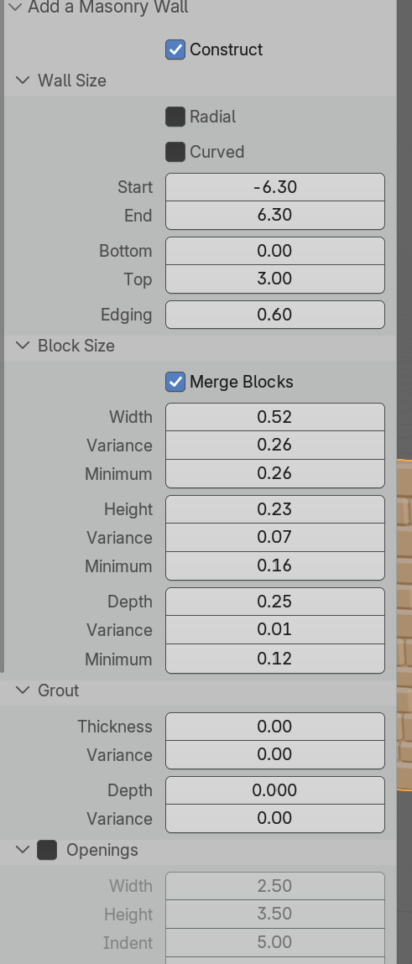
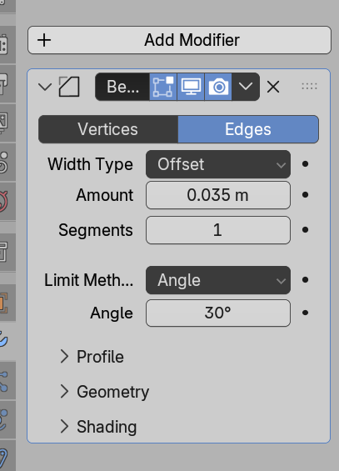
!! Add grout, 0.005 or
Workflow
Build wall to above settings; ADD GROUT!
Add Bevel as above
Scale down 50%
Cut openings
Add Boolean -> one for circle, one for rectangle -> do both separately
Add grout wall and add Booleans to it
Colour bricks
Rejoin wall bricks
Apply simple deform bend possibly resize straight after
Apply deform bend to grout wall also
Move frame (resize to 0.25)
Move door
Add grout?!?!? Setting for grout wall below – rescale, tweak, and cut openings
